# S:\CMB\Comms\12 Branding\Integration branding\Australian Aid Identifier 2013\Australian Aid Identifier colour.jpg

# **Islam in Indonesia Postgraduate Workshop**

## 1 June 2016

This workshop has been organised by the Department of Political and Social Change (PSC), College of Asia and the Pacific, in conjunction with UNSW Canberra. We would like to express our appreciation to Dr Minako Sakai of UNSW Canberra for her support and collaboration.

Funding for this workshop has been generously provided by Australian Aid, DFAT, as part of the Partnership in Islamic Education Scholarships (PIES) program.

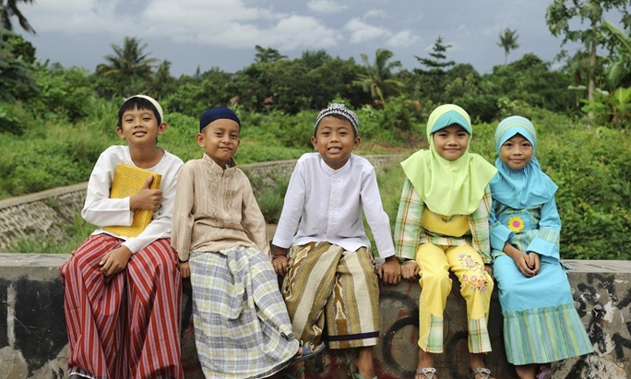

## Venue: APCD Board Room, Level 2 Hedley Bull Centre, ANU

Organisers: Greg Fealy and Sally White

# Islam in Indonesia Workshop 1 June 2016 Program

### 8.45 – 9.00 Registration

Opening remarks: Greg Fealy

## 9.00 – 10.30 **Session one**

Chair: Minako Sakai

**Speakers**:

**Muhammad Riza Nurdin**. Islamic Faith-Based Organization (FBO) and Social Capital in Disaster Recovery: The Case Study of Wallet for the Poor in 2013 Gayo Earthquake of Central Aceh, Indonesia

**Saparudin**. The Rising of Exclusivism in Contemporary Formal Islamic Education: The Case of Salafist School in Lombok, East Indonesia

**Iksan K. Sahri**. Pesantren World and the State: Pesantren salaf response to Education reform Agenda in Indonesia

### 10.30 – 11.00 Morning tea

## 11.00 – 12.30 **Session two**

Chair: Virginia Hooker

**Speakers**:

**Ahmad Muhajir**. Vote buying and psychological discomfort: dissonance among Muslim legislative candidates in Indonesia

**Syahbudi.** Nationalist Islamic Intellectual Activism and Its Contribution to Shape Relation between Islam and the State in Indonesia

**Bayu Dardies**. Islam in the Contemporary Court of Yogyakarta

**Nova Effenty Muhammad**. Interfaith marriage in Indonesia: A study of the 2005 MUI fatwa

### 12.30 – 13.30 Lunch. PSC Reading Room, Level 4.

## 13.30 – 15.00 **Session three**

Chair: George Quinn

**Speakers**:

**Bhirawa Anoraga**. Mudarabah Financing, Between Idealism and Reality

**Ray Yen**. Rumours of Wickedness Deviance Entrepreneur, Google Experts, and Manipulative Thugs

**Arhanuddin**. Interfaith dialogue in Indonesia: A Critical Assessment of Interfidei Association’s Sekolah Lintas Iman (SLI) Program in Yogyakarta

**Tingting Luo**. How democratic is Indonesia? Indonesian democracy and religious pluralism, with a particular focus on the role of Islam

### 15.00 – 15.30 Afternoon tea

## 15.30 – 17.00 **Session four**

Chair: Greg Fealy

**Speakers**:

**Syamsul Rijal**. Preaching Traditional Islam: Habāib and Religious Authority in contemporary Indonesia

**Umar Assegaf**. Legitimacy and network: the spread of Alkhairaat institution in Eastern Indonesia

**Muzaiyana**. Portrait of a Sufi movement in Indonesia: A Case Study of Tijaniyyah in Madurese society

**Colum Graham**. Knotted belonging: The interest of Wahidiyah in a rural East Javanese village

### 18.00 Workshop dinner: Delhi 6, 14 Childers St